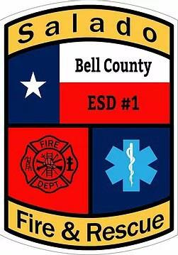
Bell County Emergency Services District No. 1 Board of Commissioners
Regular Session Meeting Agenda
March 17, 2022

Notice is hereby given that the Board of Commissioners of Bell County ESD No. 1 will meet in regular session at Salado Fire Station #2 located at 3520 FM 2484 - Salado, Texas 76571 on Thursday, March 17, 2022 at 1:00 p.m. in compliance with the provisions of Chapter 551, Texas Government Code.

- Establish quorum/Call to Order/Pledges/Invocation

- Public Comment- In accordance with the Texas Attorney General’s opinion, any public comment that is made on an item that is not on the published final agenda will only be heard by the Board of Commissioners. No formal action, discussion, deliberation, nor comment will be made by the Board of Commissioners. Individual members of the public may address the Board for a maximum of three minutes on items not on the current agenda.

- Approve the minutes of the January 20, 2022 Regular Session.

Presentation/Action Agenda
- Receive monthly report from the Salado Fire Chief regarding emergency operations, response times, call volume, management activities, training, personnel, and public information.

- Discuss and consider action on Treasurer report and outstanding bill obligations.

- Discuss and consider Action on Reimbursement of expenses and per-diem.

- Discuss and consider action for the monthly submission of expenditures and budget.

- Discuss and consider action on Annual Audit requirements

- Discuss and consider action on Collateral Agreement.

- Discuss and consider action on long range planning committee.

- Discuss and consider action on writing investment policy.

- Discuss and consider bookkeeping services.

- Discuss and consider next meeting date and future agenda items.

ADJOURN

A packet containing all supportive documentation for this agenda is available for inspection at 3520 FM 2484, Salado, Texas 76571, between the hours of 8:00 a.m. and 5:00 p.m.

Don Engleking, President
Bell County Emergency Services District No. 1

The Board may retire to Executive Session any time between the meeting's opening and adjournment for any purpose authorized by the Texas Open Meetings Act, including but not limited to: consultation with legal counsel (Section 551.071 of the Texas Government Code); personnel matters (Section 551.074) and/or discussion of real estate acquisition (Section 551.072). Action, if any, will be taken in open session.

Bell County Emergency Services District No. 1 is committed to compliance with the Americans with Disabilities Act. Reasonable modifications and equal access to communications will be provided upon request. Please call Ashley Voss-Liebig, Secretary for Bell County Emergency Services District No. 1 at (309) 269-0439 for information. Hearing impaired or speech disabled persons equipped with telecommunication devices for the deaf may utilize the statewide Relay Texas Program by dialing 7-1-1 or 1-800-735-2988.

